Appendices

Section1
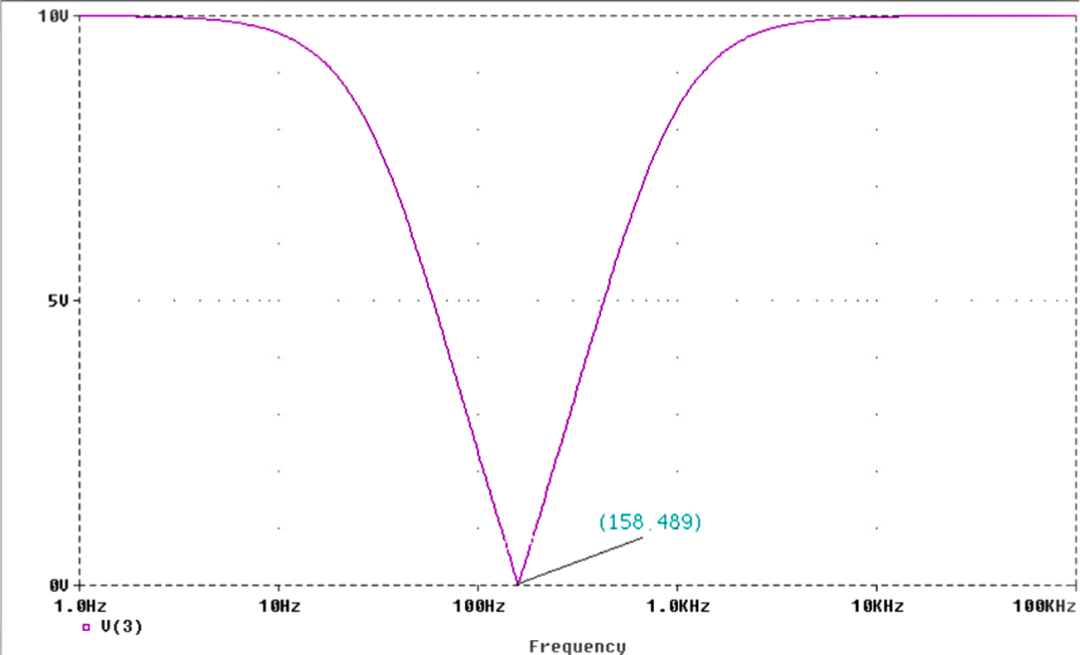
[Graph. 15]

Section2

[Table.1] Effect of R1 decreased by a factor of 2
2 x R1 (ohms) | R2 (ohms) | 2 x C1 | C2 | Stop Band (Hz) | Reject Frequency (Hz) | Min (V) Passed Through
1k | 500 | 1uF | 2uF | 636.668 | 158.489 | 0
500 | 500 | 1uF | 2uF | 1053.485 | 281.838 | 1
250 | 500 | 1uF | 2uF | 1923.56 | 562.34 | 2.1
125 | 500 | 1uF | 2uF | 3664.873 | 1174.9 | 2.7
62.5 | 500 | 1uF | 2uF | 7048.046 | 2454.7 | 3
31.25 | 500 | 1uF | 2uF | 13771.7 | 5011.9 | 3.2
15.625 | 500 | 1uF | 2uF | 27218.9 | 10000 | 3.3

By keeping the values of R1, R2 & C2 consistent with the values used in the first part of this assignment, but decreasing the value of R1 by a factor of 2, for each analysis. It can be seen that the reject frequency shifts and stop band increases by a factor of two.

2 x R1 (ohms) | R2 (ohms) | 2 x C1 | C2 | Stop Band (Hz) | Reject Frequency (Hz) | Min (V) Passed Through
1k | 250 | 1uF | 2uF | 896.906 | 194.985 | 0.6
1k | 125 | 1uF | 2uF | 1478.622 | 239.883 | 0.8
1k | 62.5 | 1uF | 2uF | 2711.601 | 309.03 | 0.8
1k | 31.25 | 1uF | 2uF | 5234.359 | 396.107 | 0.7
1k | 15.625 | 1uF | 2uF | 10315.02 | 512.861 | 0.5
1k | 7.8125 | 1uF | 2uF | 20494.847 | 660.693 | 0.3
[Table.2] Effect of R2 decreased by a factor of 2
2 x R1 (ohms) | R2 (ohms) | 2 x C1 | C2 | Stop Band (Hz) | Reject Frequency (Hz) | Min (V) Passed Through

By keeping the values of R1, C1 & C2 consistent with the values used in the first part of the assignment, but decreasing the values of R2 by a factor of 2, for each analysis. It can be seen again that the reject frequency shifts and stop band increases by a factor of two.

2 x R1 (ohms) | R2 (ohms) | 2 x C1 | C2 | Stop Band (Hz) | Reject Frequency (Hz) | Min (V) Passed Through
1k | 500 | 2uF | 2uF | 352.048 | 91.201 | 1
1k | 500 | 4uF | 2uF | 191.148 | 45.709 | 2.1
1k | 500 | 8uF | 2uF | 88.3139 | 21.308 | 2.7
1k | 500 | 16uF | 2uF | 34.5234 | 10.233 | 3
1k | 500 | 32uF | 2uF | 14.92 | 5.1286 | 3.2
1k | 500 | 64uF | 2uF | 6.981801 | 2.5119 | 3.3
[Table.3] Effect of Increasing C1 by a factor of 2

By keeping the values of R1, R2 & C2 consistent with the values used in the first part of the assignment, but increasing the values of C1 by a factor of 2, for each analysis. It can be seen again that the reject frequency shifts down by a factor of two and the stop band increases by a factor of two.

2 x R1 (ohms) | R2 (ohms) | 2 x C1 | C2 | Stop Band (Hz) | Reject Frequency (Hz) | Min (V) Passed Through
1k | 500 | 1uF | 4uF | 595.376 | 131.826 | 0.6
1k | 500 | 1uF | 8uF | 575.498 | 104.713 | 0.8
1k | 500 | 1uF | 16uF | 566.662 | 83.176 | 0.8
1k | 500 | 1uF | 32uF | 562.6446 | 64.565 | 0.7
1k | 500 | 1uF | 64uF | 560.6909 | 50.119 | 0.5
1k | 500 | 1uF | 128uF | 559.7238 | 38.019 | 0.3
[Table. 4] Effect of Increasing C2 by a factor of 2

By keeping the values of R1, R2 & C1 consistent with the values used in the first part of the assignment, but increasing the values of C2 by a factor of 2 for each analysis. It can be seen that the reject frequency shifts downwards by a small amount, after each set of results this difference gets incrementally smaller, this pattern is reflected in the reject frequency figures.

When analysing the circuit, altering the value of one component and keeping the rest at a constant value, the resultant of this was the reject frequency and band stop frequency altered simultaneously. It is required that the reject frequency is kept the same but the band stop frequency is altered. In this system there is a mechanism which keeps the potential at V_{out} the same.

Starting with the component values used in part 1, lets increase the capacitive reactance of C1 in Y₁ by a factor of two (which is exactly the same as decreasing its capacitance by a factor of two) and increase the resistance of R1 in Y₂ by a factor of two.

2 x R1 (ohms) | R2 (ohms) | 2 x C1 | C2 | Stop Band (Hz) | Reject Frequency (Hz) | Min (V) Passed Through
2k |  | 500nF |  | 868.207 | 158.489 | 0.91
4k |  | 250nF |  | 1492.582 | 158.489 | 0.81
8k |  | 125nF |  | 2718.8271 | 158.489 | 0.5
16k |  | 62.5nF |  | 5258.2874 | 158.489 | 0.29
32k |  | 31.25nF |  | 10297.6 | 158.489 | 0.15
[Table. 5] Effect of Decreasing C1, increasing R1 by a factor of 2

Now, the reject frequency has been kept constant, i.e. for an A.C. input frequency of 158.489 Hz the potential at V_{out} is equal to zero.

For the bridge to be balanced, the impedances must satisfy

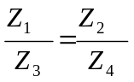

or, equivalently

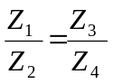

So there is an easy mathematical balance equation to express the passive notch filter circuit. Now, altering values for the individual impedances can be thought out more logically. The value for the rejected frequency needs to be kept at a constant value, all that needs altering is the stop band (the notch). So, the equation needs to balance in order to reject the same frequency (observed in the trial above). Thus it can be shown that increasing Z₁ in proportion to Z₃ should keep the cut off frequency at the same level, same can be said about variables Z₂ and Z₄ etc.

A table of results is shown below to verify these interpretations:

2 x R1 (ohms) | R2 (ohms) | 2 x C1 |  | C2 |  |  | Stop Band (Hz) |  | Reject Frequency (Hz) |  | Min (V) Passed Through
500 |  |  | 2u |  |  | 594.833 |  | 158.489 |  | 2.5
250 |  |  | 4u |  |  | 557.13 |  | 158.489 |  | 5.45
125 |  |  | 8u |  |  | - |  | - |  | Too much (over 7.07 V)
[Table. 6] Effect of Decreasing R1, Increasing C1 by a factor of 2

[Table. 7] Effect of Decreasing R2, Increasing C2 by a factor of 2

2 x R1 (ohms) | R2 (ohms) | 2 x C1 |  | C2 |  |  | Stop Band (Hz) |  | Reject Frequency (Hz) |  | Min (V) Passed Through
 | 250 |  |  |  | 4u | 868.207 |  | 158.489 |  | 0.91
 | 125 |  |  |  | 8u | 1457.582 |  | 158.489 |  | 0.81
 | 62.5 |  |  |  | 16u | 2718.8148 |  | 158.489 |  | 0.51

[Table. 8] Effect of Increasing R1/C2, decreasing R2/C1 by a factor of 2

Notice the effect of decreasing R2 in proportion to the increase in C2 has exactly the same effect as increasing R1 in proportion to the decrease in C1. In both cases the reject frequency stays constant but the stop band (the notch) increases. Increasing the notch width at a certain reject frequency, effectively lowers the voltage pass. Using the convention, C2 = 2*C1 and R2=R1/2, gives the greatest effective balance between the minimum voltage passed through at a desired cut off frequency, to the bandwidth of the stop band (both values are small).The filter operates more effectively at these values.

2 x R1 (Ohms) | R2 (Ohms) | 2 x C1 | C2 | Stop Band (Hz) | Reject Frequency (Hz) | Min (V) Passed Through
1k | 500 | 1uF | 2uF | 636.668 | 158.489 | 0
2k | 250 | 0.5u | 4u | 1462.682 | 158.489 | 0.8
4k | 125 | 0.25u | 8u | 5258.4874 | 158.489 | 0.28
8k | 62.5 | 0.125u | 16u | 20534.7665 | 158.489 | 0.076

[Table. 9] Effect of Decreasing R1/C2, increasing R2/C1 by a factor of 2

500 | 1k | 2u | 1u | 557.13 | 158.489 | 5.45
250 | 2k | 4u | 0.5u | - | 158.489 | 8.78
- | - | - | - | - | 158.489
Now if Z₃ and Z₁ are increased in proportion to the decrease in Z₄ and Z₂ , the results can be worked out before any analysis is done using Pspice. As thought the results are the same as the results shown in the previous exercise, instead the stop band is a factor of 2 higher than results in the same transition in the previous table.

Section3

This part is simple, from PART1 of the assignment the cut off frequency was found to be approximately 160 Hz, the capacitances are known. Hence using phasors :

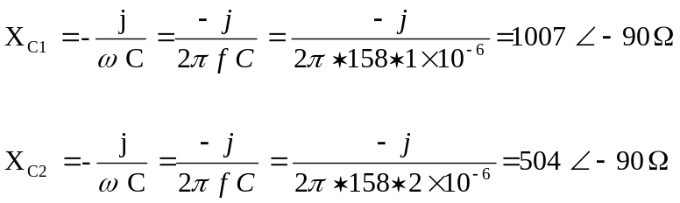

So to reject 2kHz we require Xc₁ = 1k , Xc₂ = 500 .
But what capacitance do we use?

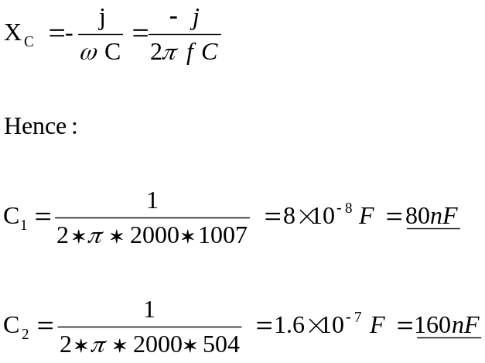

Section4

In the first filter circuit (This is required to block a frequency of 100Hz) the required resistor values are:-
(1)
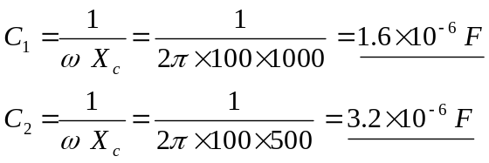

In the second filter circuit (This is required to block a frequency of 1MHz) the required capacitor values are:-

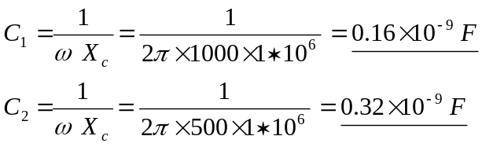

Because this filter is ineffective at rejecting one and two particular frequencies. The limit of effectiveness shall be stated as follows. If the cascaded filters rejects two bands of frequencies (below 70% of the supply voltage) but has three pass bands (above 70% of the supply voltage) i.e. Passes a frequency band in between the two stated reject frequencies (as well as the left and right pass band) then this is an effective filter. Hence if the middle (pass) band just about falls below this 70.7% of the supply voltage value then the filter at this point is ineffective.

Okay, lets see what happens if the frequency between the two reject frequencies is reduced. The first filter will now reject a frequency of 1kHz and the second filter will reject a frequency of 100kHz. Lets see how effective the filter is at filtering both the frequencies.

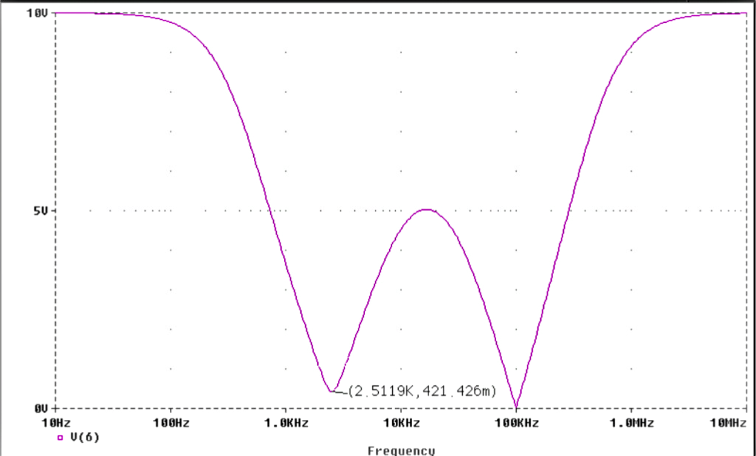
[Graph. 16] The cascade of filters coping with the reject frequencies of 1 & 100kHz

The filter nicely rejects the 100 kHz frequency, but look, because the reject frequencies are too close together the filter hasn’t rejected 1kHz fully ( when the frequency of the A.C. signal is 1kHz the filter lets through approximately 4 volts of the input signal). Plus the filter also rejects all the frequencies in between 900 Hz and 500kHz (not good!). Lets now expand the frequency difference between the two reject frequencies. To say around 500 Hz – 500 kHz.

In the first filter circuit (This is required to block a frequency of 500Hz) the required resistor values are:-

(2)
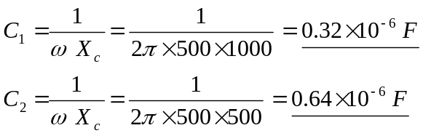

In the second filter circuit (This is required to block a frequency of 500kHz) the required capacitor values are:-

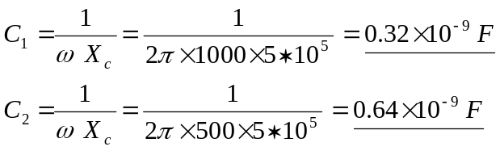
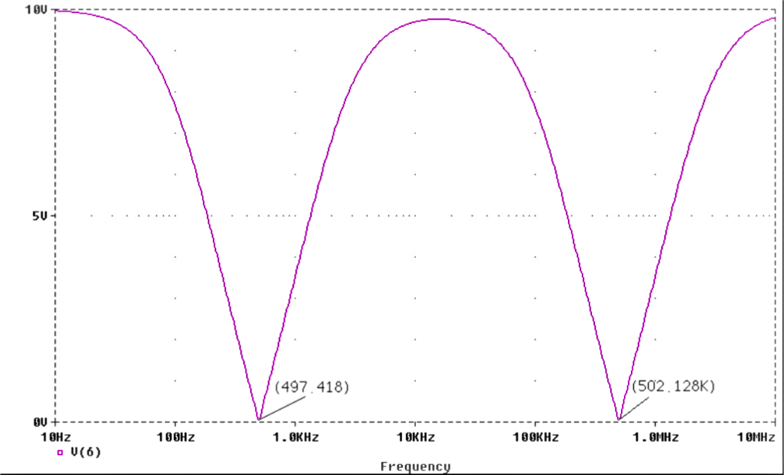
[Graph. 17] The cascade of filters coping with the reject frequencies of 500 & 500kHz

As the graph shows, these two frequencies are rejected perfectly well passing a band of frequencies in between these limits. Hence it is known that the frequency limit between the two cut off frequencies lies in between (500 – 1000)Hz – (100 – 500)kHz. So trying out a reject frequency of 750Hz in the first of the two cascading filters, and a reject frequency of 250kHz in the second filter.

In the first filter circuit (This is required to block a frequency of 750Hz) the required resistor values are:-

(3)
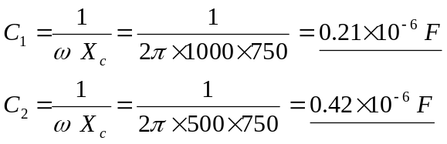

In the second filter circuit (This is required to block a frequency of 250kHz) the required capacitor values are:-

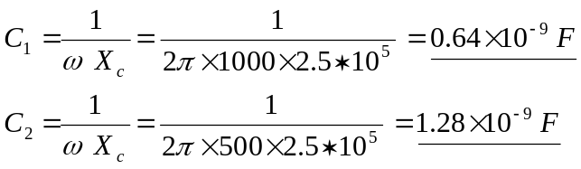

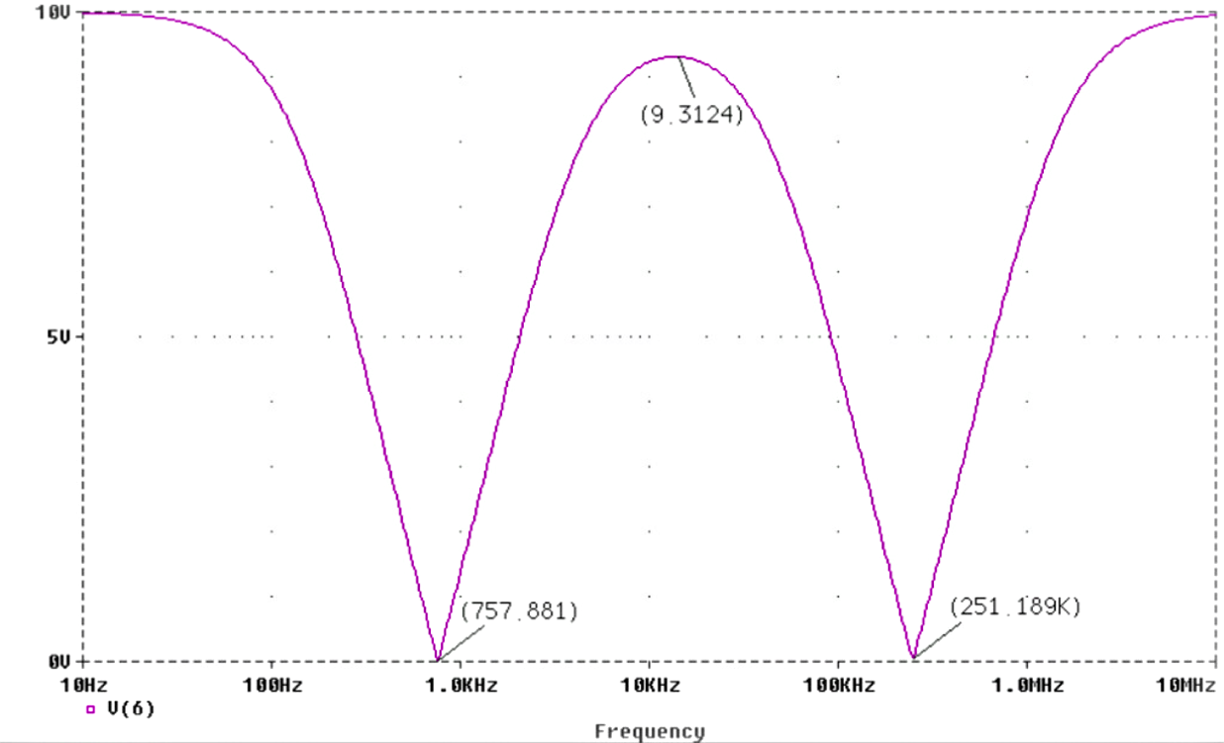
[Graph. 18] The cascade of filters coping with the reject frequencies of 750 & 250kHz

Lets try a slightly wider “effective width for rejection”. A reject frequency of 625Hz in the first of the two cascading filters, and a reject frequency of 125kHz in the second filter shall be used.

In the first filter circuit (This is required to block a frequency of 625Hz) the required resistor values are:-
(4)
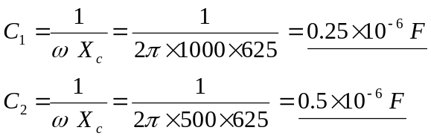

In the second filter circuit (This is required to block a frequency of 125kHz) the required capacitor values are:-

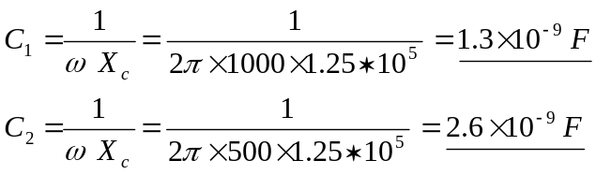

In the first filter circuit (This is required to block a frequency of 562.5Hz) the required resistor values are:-
(5)
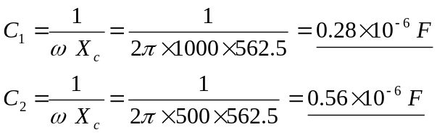

In the second filter circuit (This is required to block a frequency of 62.5kHz) the required capacitor values are:-

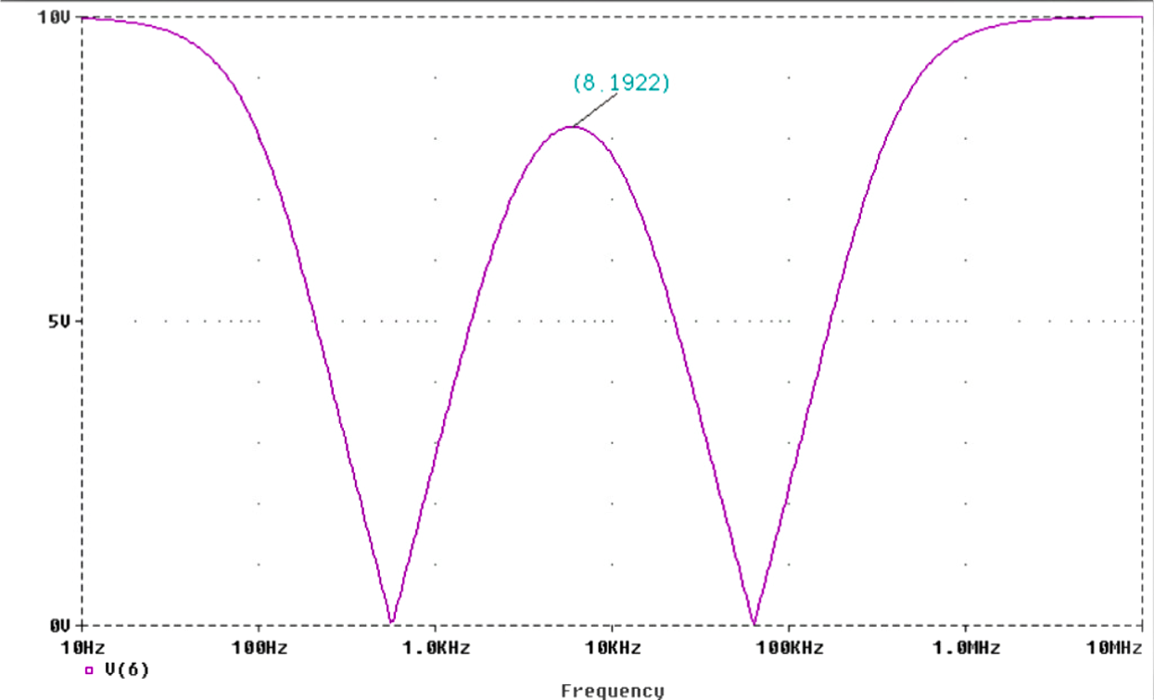
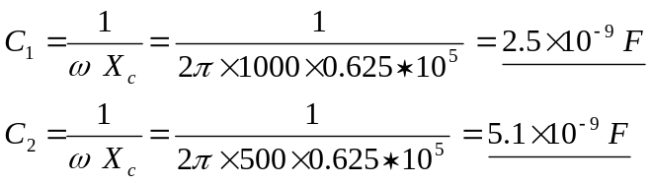

[Graph. 19] The cascade of filters coping with the reject frequencies of 562.5 & 62.5kHz

In the first filter circuit (This is required to block a frequency of 531.25Hz) the required resistor values are:-
(6)
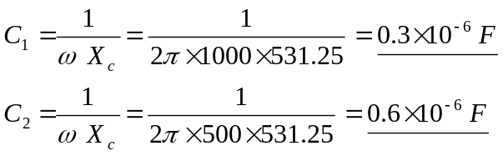

In the second filter circuit (This is required to block a frequency of 31.25kHz) the required capacitor values are:-

